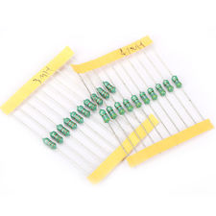

**Utility 200pcs 20 Value Assorted Color Wheel Inductor Kit 1/2W 10% Tolerance Set**

1. 100% Brand new and high quality<br>
2. This Color Wheel Inductor kit will promote your work efficiency, and help to save your time and money<br>
3. Power Rating: 0.5 Watt<br>
4. Tolerance: 10% <br>
5. Value list: 220UH, 330UH, 470UH,   0.22UH, 150UH, 10UH, 47UH, 1UH, 100UH, <br>
6. 4.7UH,3.3UH, 33UH, 15UH, 6.8UH, 1MH, 4.7MH, 3.3MH, 2MH, 2.2MH, 680UH <br>
7. Color Wheel Inductor length: Approx. 6cm<br>

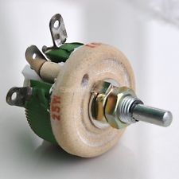

25 W 50 OHM HIGH POWER WIREWOUND RHEOSTAT

Rs 200

1. **50 ohm 25 Watts High Power Ceramic Wirewound Potentiometer / Rheostat.**
2. **Quantity: 1 piece.** <br>
3. **Rated current: 0.71 Amp.** <br>
4. **Size: A=43mm, B=40mm, F=50mm, L=24 +/-1mm.** <br>
5. **Shaft Diameter: 6mm.** <br>

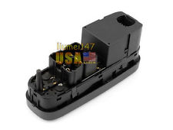

**New Electric Power Window Master Control Switch For 1998-2000 Volvo V70 XC70 S70**

**Rs 2000**

1. Steel mills, petroleum/chemical plants, power plants, <br>
2. Heavy industries. The SB-9 master control switches <br>
3. Recommended for applications large number of repetitive <br>
4. Operations with positive positioning on each operation. <br>

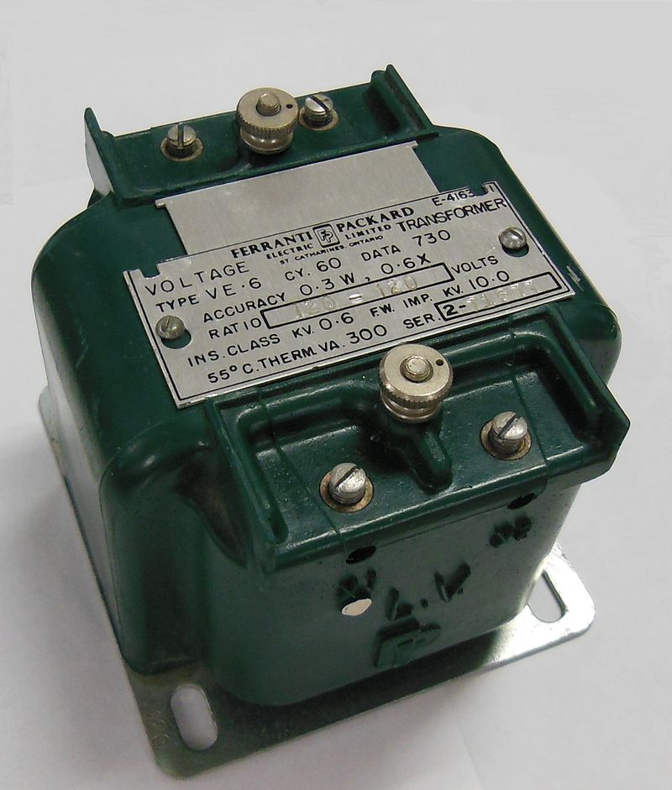

Instrument transformer, with polarity dot and X1 markings on LV side terminal

1. The name instrument transformer is a general classification applied to current and voltage devices used to change currents and voltages from one magnitude to another or to perform an isolating function, that is, to isolate the utilization current or voltage from the supply voltage for safety to both the operator and the end device in use. <br>
2. Instrument transformers are designed specifically for use with electrical equipment falling into the broad category of devices commonly called instruments such as voltmeters, ammeters, wattmeters, watt-hour meters, protection relays, etc<br>

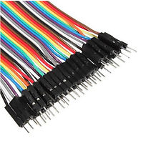

**40pcs Dupont 10CM Male To Female Jumper Wire Ribbon Cable For Arduino Best**

Rs 150

1. Length: 10cm<br>
2. 100% brand new and high quality. <br>
3. Quantity: 40pcs/lot (A row of 40 root) <br>
4. Male to Female 1p-1p pin header<br>
5. Easy to install and use<br>
6. 40pcs chromatic color male to female dupont cables. <br>
7. Durable and reusable. <br>
8. High quality. <br>
9. A popular choice for construction or repair. <br>

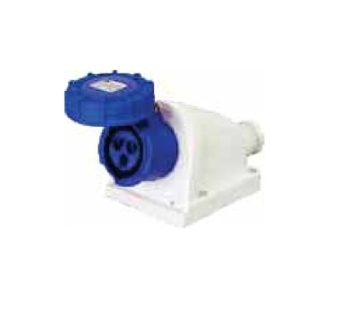

C&S CS 62437 Surface Mounting Socket (2 Poles + Earthing, 32A)

Rs. 866

1. Model No.: CS 62437 <br>
2. Product Type: Surface Mounting Socket<br>
3. No. of Poles: 2P + Earthing<br>
4. Rating: Current (Ampere) 32<br>
5. Protection Type: IP 67 <br>
6. Mounting: Water Tight<br>